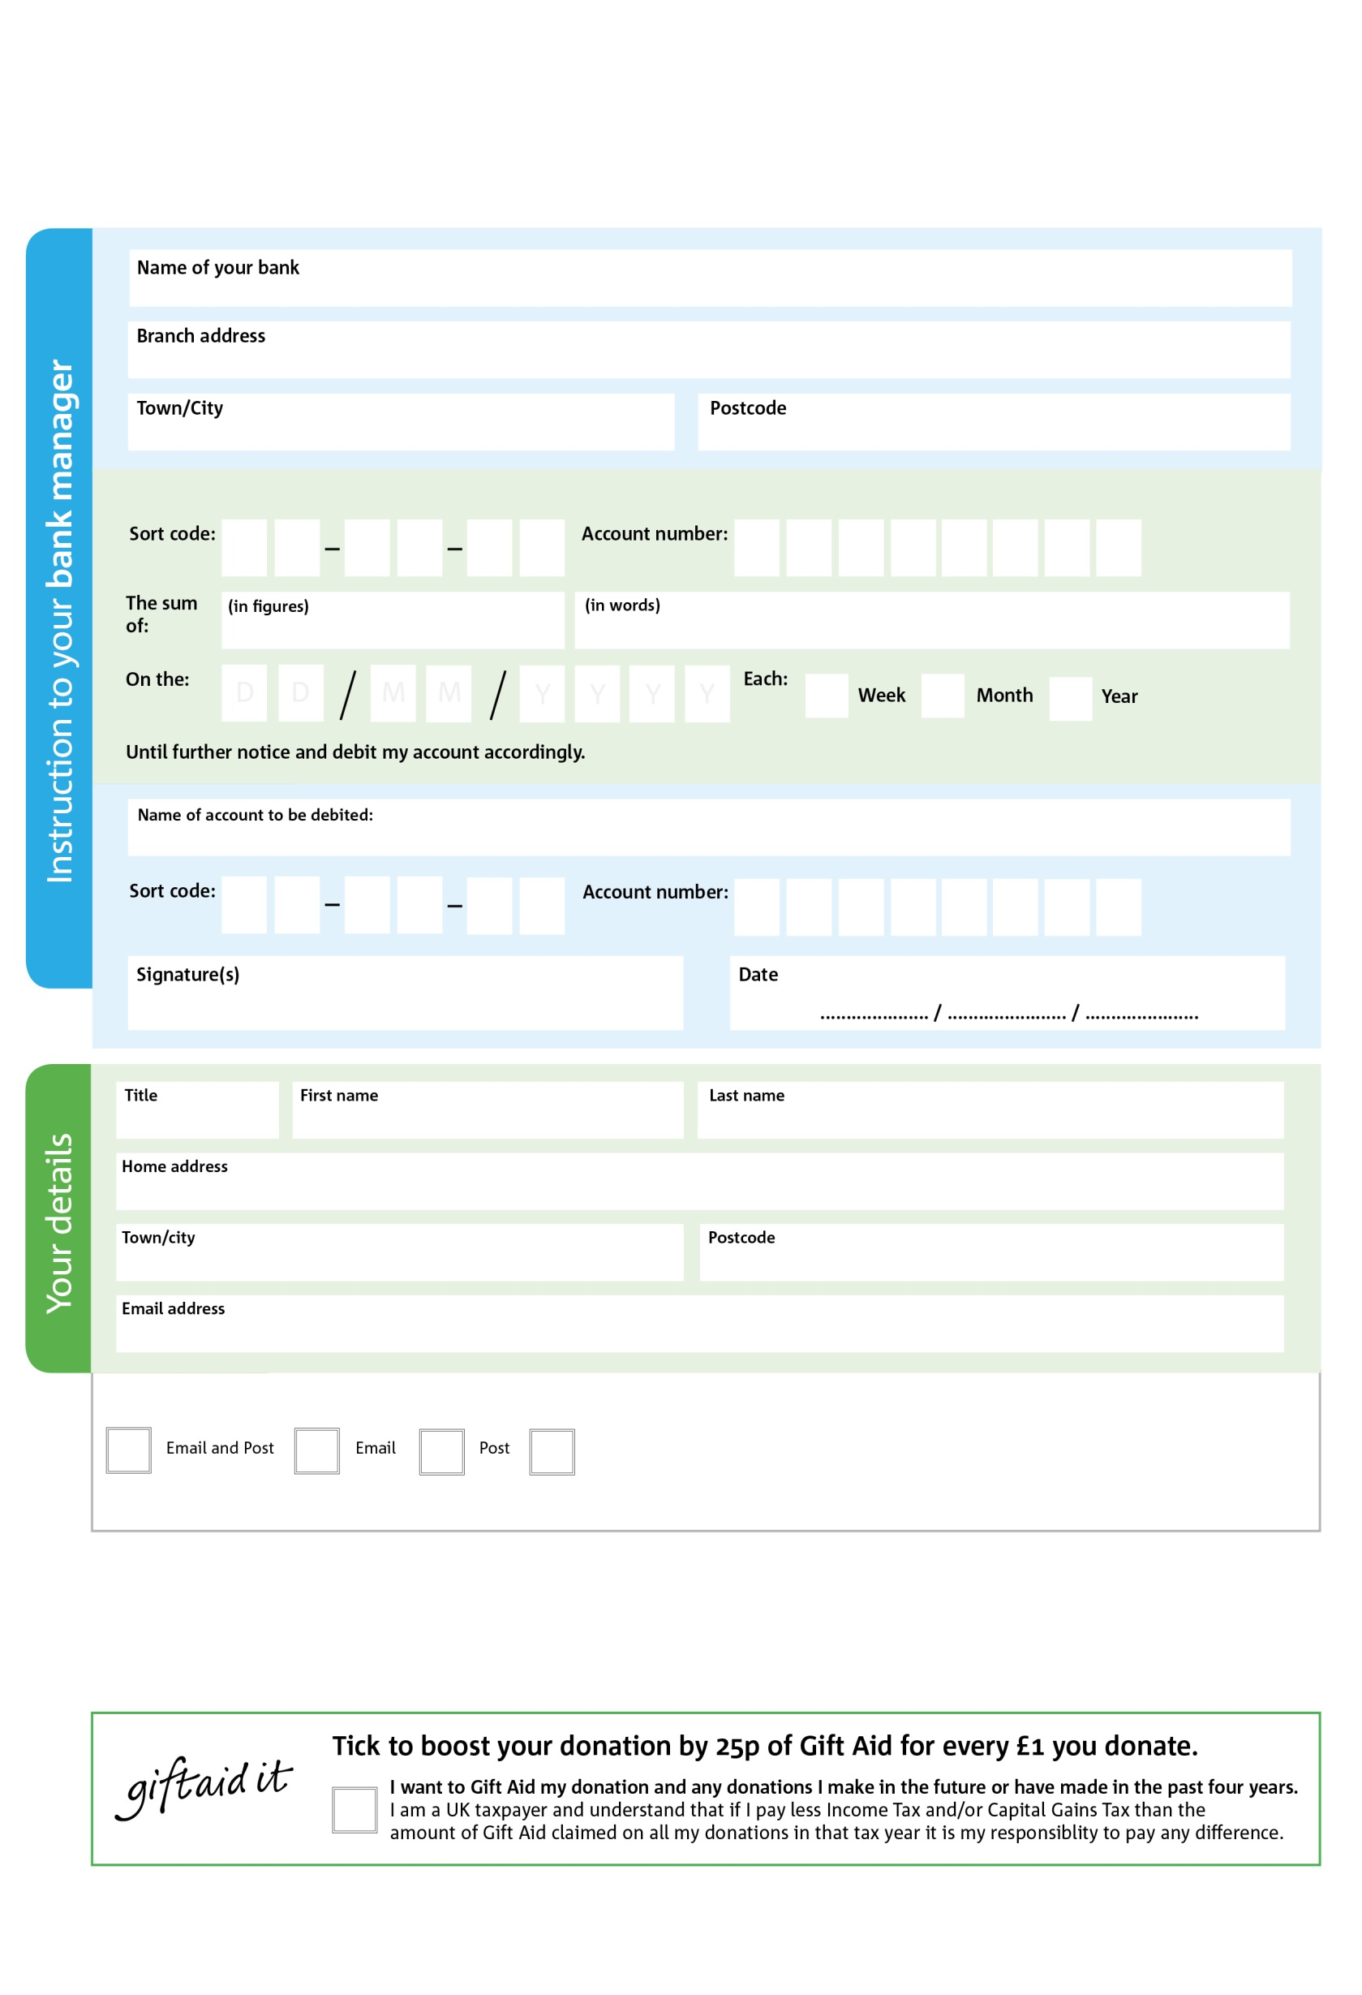

6

You can change your preferences any time by emailing us at info@highbridgearea.foodbank.org.uk

I do not wish to receive future communications from Highbridge Area Foodbank

Please pay Highbridge Area Foodbank Foodbank,

POSTAL ADDRESS: Highbridge Area Foodbank, c/o Hope Baptist Church, Church Street, Highbridge TA9 3HW

Reg. Charity No: 1147076 | Reg. in England & Wales

000

V

33

V33

55

V

33

V

77

V

333

V

22

V

7

7

7

9

0

3

We would love to keep you up to date with information aboutHighbridge Area Foodbank. Please tick your preference:

**Data protection**

*Highbridge Area Foodbank is committed to protecting your privacy and will process your personal data in accordance with current Data Protection legislation. Highbridge Area Foodbank collects information to keep in touch with you and supply you with information relating to our work. To unsubscribe from our newsletter, send a message to the email address above with the word unsubscribe in the subject line. A full data privacy statement for financial donors is available from the foodbank on request.’*

**Standing Order Mandate**

**highbridgearea.foodbank**.org.uk

You can change your preferences any time by contacting us on XXXXXXXXXXX or emailing us at XXXX@XXXXXXXXXX.foodbank.org.uk

I do not wish to receive future communications from XXXXXX Foodbank